Duel Up 
(July 23, 2024)
Duel Up is a two-player game that combines strategy, quick thinking and a bit of luck, all on a vertical tower! Without knowing what their opponent is making, players drop tiles to form words or “triplets”.
Spelling and arithmetic in an easy-to-play game.

LASERCUT COMPONENTS  - Eight-story wooden tower with 24 see-through windows  - Base with built-in score tracks  - Two acrylic pegs for scoring  - 40 two-sided wooden tiles with opposing numbers and letters  - Wooden box. | 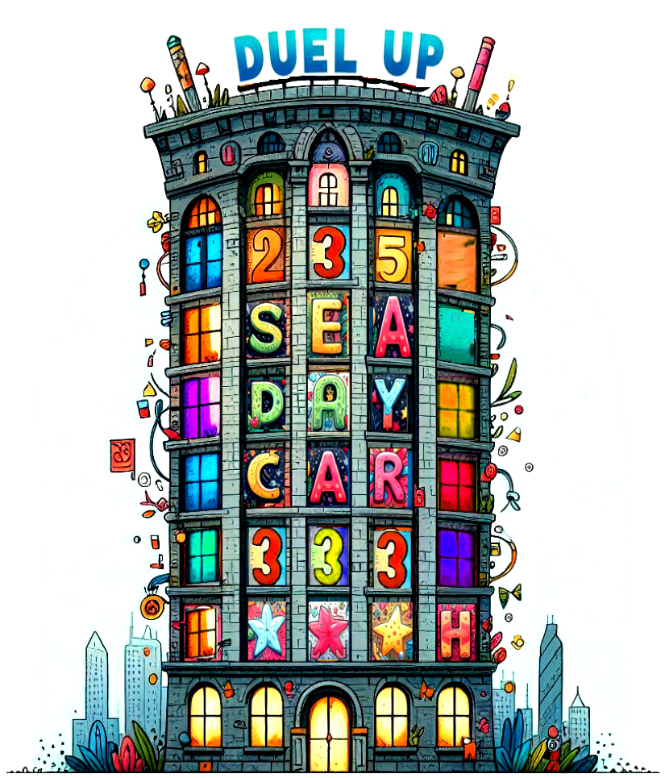
SETUP
- Insert the tower into its base on your table.
- Each player faces opposite sides of the tower.
- Spread all the tiles face up.
- Each player takes half of the tiles.
- One person flips all of their tiles to show letters.
- One person flips all of their tiles to show numbers.

GAME PLAY
You take turns dropping a single tile into one column. Drop either a letter or a number. Do not mix them up. Make sure that when you drop your tile, it is oriented corrected - that is, if you are playing letters, the letter faces you.

Note that each player can only see their side of the tower – no peeking!

Letters Goal:
The player dropping letters will be attempting to make words of at least three letters. These words can be in any of eight directions.

Triplets Goal:
A “triplet” comprises three adjacent numbers that either …
- Add up to ten (3+4+3) or
- All have the same number (1,1,1).
Triplets can only be formed horizontally.
PLAY IN ROUNDS
Game play is in rounds. Play at least four rounds. On each round, players will alternate playing with either letters or numbers. Between rounds, players will swap their goals.

FINDING WORDS  Words comprising three or more adjacent letters in a straight line can be found in any of eight directions.  Example:  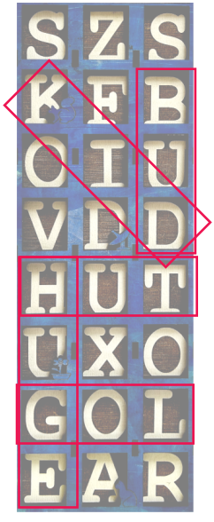 | KID  HUG  HUT  LOG  EAR  LOT  BUD  Score: 7 | MAKING TRIPLETS  Count horizontal sets of three adjacent numbers whose sum adds up to ten and count horizontal sets of identical numbers.  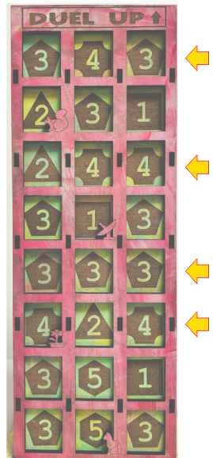 | Count the number of sums to ten across the rows only.  Include any sets of three identical horizontal numbers.  In this example, there are four triplets.  Score: 4

SCORING
Once the tower is filled, each player indicates how many words or triplets they have made. Look in all directions. Verify each word or triplet with your opponent. Advance your score on your score tracker.

BONUS POINTS
Any player finding one word or triplet that their opponent missed will collect an additional point.

After scoring, turn the tower upside down to dump out the letters. Separate the tiles into two groups again. Start a new round, swapping your goals.

WINNING
The first player to exceed 30 points (or a predetermined target) will be the winner. In case of a tie, play two more rounds.

RAPID MODE
Instead of taking turns dropping tiles, play simultaneously for a fast-paced game of quick-thinking!

SEND US A PHOTO OR VIDEO
Please post a photo or video of your family playing the game. Tag #duelup and @brainy.games on Instagram. We’ll mail you a free memory game as thank you gift.

Copyright © 2024 Knowledge Probe Inc.
www.Brainy.games

